Non-Governmental Organization Funding with Blockchain
1st Sumit Kumar  Department of IT  ABES Institute of Technology  Ghaziabad, India sumit.kumar@abesit.in | 2nd Himanshu Vashistha  Information Technology  ABES Institute of Technology  Ghaziabad, India himanshuvashistha552@gmail.com | 3rd Deepanshu Kumar  Information Technology  ABES Institute of Technology  Ghaziabad, India dipanshuroy584@gmail.com
4th Sharad Singhal
Information Technology
ABES Institute of Technology
Ghaziabad, India
singhalsharad04@gmail.com

Abstract—Although a relationship between NGOs and their donors is based more on trust, donors would expect NGOs to demonstrate legitimacy and accountability this time. Transparency is at the core of building such confidence, and recent technological innovation advances, specifically blockchain, reveal new possibilities for greater accountability in the NGO sector. Blockchain is a trust less system that can confirm transactions on its own without the assistance of an external party, thus building trust between NGOs and donors. There are various major domains related to the application of blockchain in the NGO sector. Many research gaps exist regarding effective knowledge of blockchain compared to other approaches that validate its effectiveness in promoting transparency and accountability. Research has shown that blockchain technology has a high-efficiency level of about 95% in increasing the reliability of donation-tracing mechanisms. However, almost 90% of non-governmental organizations (NGOs) are reluctant to adopt such innovations. The most significant technologies driving such innovations include blockchain, smart contracts, decentralized applications (DApps), distributed ledger technology (DLT), and data analytics, which all play a vital role in increasing transparency in donation systems. While blockchain has tremendous potential to transform the way NGOs engage with donors, organizations are faced with severe challenges in its application. Such challenges tend to come from change resistance and the difficulty in adopting and maintaining new technologies. The need to carry out comprehensive research to overcome such challenges and investigate how blockchain can increase transparency and accountability in NGO operations remains the number one priority.
Keywords--NGOs, Donors, Blockchain, Smart Contracts, Dapps, DLT, Data Analytics, Transparency.

I. INTRODUCTION
The government and the donors give the funds for the work done by the NGOs. They think that these NGOs will help in the development in the different parts of the world. But many times, it was very difficult for the donors to know about the use of their given funds. The image of NGOs has been significantly affected due to old corruption scandals. However, NGOs had already established a good image worldwide. NGOs do hard work to awareness raise in foreign people. but they cannot reveal the use of money through individual contributions. NGOs are under attack due to a lack of transparency and accountability. The demand for information on the expenditure of these organizations is increasing, especially in cases where NGOs operate across the borders of several countries. The most likely outcome of setting a benchmark for full transparency and accountability within NGOs would be a reduction in the incidence of fraud and misappropriation of funds that typically characterize these entities. However, there are economic and social factors that can influence the level of transparency that an NGO can achieve. It has recently become apparent that the implementation of blockchain technology in the NGO sector is under survey, particularly issues related to the problems associated with increased transparency in donation procedures. This is due to the trust factor, which is essentially the foundation of the relationship between NGOs and their donors. Donors expect that all contributions made to the NGO will be used to the maximum and that the NGO will be accountable. However, fraud, lack of transparency, and issues related to the origin of donations have been obstacles in the sector. Innovations that address these issues are in demand. The blockchain-based donation systems must be designed with scalability, fraud reduction, and even donor trust in mind. This is the ability to use blockchain technology, one of the emerging promising areas in smart contracts and applications, which will make it easy to produce secure and transparent systems for tracking donations. The probability of transaction accuracy in the blockchain ledger and the creation of smart contracts was about 99.9% [1], This initiative most probably reduces fraudulent activities and makes sure that the right funds go directly to the right projects. Such potential solves some of the NGOs’ immediate problems while improving their credibility and integrity in operations.”
Organizations should consider incorporating blockchain technology into their sustainability education programs to enhance the transparency, verifiability, and efficiency of their sustainability-related activities [2].
These developments, many research gaps remain that the industry must address. The most effective of these is a total lack of studies regarding how effective blockchain is compared with other methods of ensuring transparency and accountability. Moreover, another very important challenge is the unwillingness of NGOs to adopt blockchain technology. It is therefore very important to understand the barriers to implementation and to look for ways to promote a culture of innovation in organizations. Solving these problems can cover the way for an even stronger framework to build donor trust and increase the overall effectiveness of NGOs in their operations [3].
While some NGOs invest their donations in microfinancing, others provide free services to local community members. In this age of technology, the Internet is one of those things that have become an integral part of our lives. "Six in ten people worldwide are now online," Kepios analysts say. Thus, most NGOs and Charities changed the form of donation to become a part of the internet, hence reachable by everybody [4]. With this internet expansion, new modes of funding are coming up like crowdfunding and peer-to-peer fundraising. The donor comfortably sees thousands of projects and charities and donates to any one of them. However, with some charity scandals of the recent past, including the Red Cross Scandal, most donors lost their trust in NGOs and charities. As per the Ministry of Financial Planning, it is contended that the average cost to raise $1 ranges from $0.05 to $0.25 depending on the method used in collecting the donation. Blockchain is a digital form of ledger where every transaction that is carried out within the same records is safe, transparent, and tamperproof [5]. It is a decentralized system that exists through a network of computers that enables the safe and efficient flow of information and value. Being at the heart of blockchain technology, it applies cryptography to secure transactions and warrant their integrity. Each transaction takes place in a block added to the chain of blocks, hence building up a chronological chain of transactions. The blockchain keeps the chain of blocks through a network of computers where, with each verifying and validating transactions, the blockchain will always have correct, updated information. Decentralization is a common feature of blockchain technology that helps to eliminate the presence of mediators between parties in a transaction; it generally provides more security because a central authority cannot manipulate or steal any data [6].
Blockchain technology, which is cryptographically secured and supported by digital signatures, maintains the integrity of data, rendering it extremely secure and reliable [7]. Blockchain enables real-time transactions, hence, the absence of middlemen and transaction delays. In the education sector, blockchain maintains efficiency, transparency, and credibility, automating back-office functions to achieve cost-effectiveness while providing credentials authenticity [8]. This technology minimizes fraud, allows learners to comfortably present their credentials, and spares employers' time during the verification process declarations [9]. Even with an enormous potential, challenges do exist in terms of limited awareness, cost, and technical complexity. Organizations have to cross hurdles of regulatory requirements, acquire needed equipment, and train staff to provide secure installations. Transcending such barriers can actualize the revolutionary potential of blockchain to transform education by enhancing access and trust. With further development in the technology, its impact on education will be substantial and worthy of observation [10].
II. LITERATURE REVIEW
So, one of the first studies looking into how blockchain tech can help NGOs with transparency and accountability came out in 2018. The results showed that blockchain did way better than the old tracking methods, boosting accuracy by 95% and handling implementation issues like a champ with a 90% resistance. This provided strong evidence that blockchain was reshaping NGO operations toward greater transparency. In 2023, researchers examined blockchain’s potential to revolutionize education. They highlighted key challenges in the current system, including scalability, privacy, adoption, and interoperability. Their study focused on technologies like smart contracts, cryptography, and oracles, revealing that blockchain ledgers provided near-perfect accuracy, with verification and authentication rates reaching 99.9%. This advancement could significantly transform the educational landscape [1].
So, back in 2021, they shared this case study about using blockchain for charity management because of the whole COVID-19 situation. The researchers showed that blockchain could really boost fundraising efficiency and cut down on fraud, hitting a 98% accuracy in spotting fraud and making fundraising more effective by 90%. This just goes to show how blockchain can really help out charitable organizations when things get tough globally. Then, in 2023, another study came out suggesting a blockchain-powered management system for NGOs, which just highlights how this tech is really making waves in the non-profit world. This study looked into how blockchain could help NGOs scale up, fight corruption, and stick to regulations. Just like the earlier studies, they also mentioned a 100% accuracy for blockchain's ledgers and 99.9% for verifying transactions; so, the discussion about bringing blockchain into the NGO sector to cut down on fraud is definitely heating up [2].
In 2023, the authors presented a benevolent blockchain system that renews public trust through increased transparency and scalability in aid delivery systems. Their study resulted in achieving 98% ledger accuracy with full security, meaning that blockchain can indeed provide real-time donation systems that are more transparent and efficient [3]. The authors’ key paper in 2022 discussed blockchain’s potential to minimize fraud and increase the transparency of NGO donations while reducing the cost of transactions. This paper has focused on blockchain technologies such as cryptocurrency, stablecoins, and decentralized finance. The results demonstrated outstanding fraud detection capabilities, achieving 97% accuracy. Additionally, the blockchain framework proved highly effective in reducing transaction fees, reaching a 95% success rate. By implementing this system, corrupt practices could be significantly minimized [4].
Over the past few years, blockchain technology has made a major change in the nonprofit organization landscape by promoting transparency and trust. In 2023, scientists created Donation Chain, a blockchain platform that concentrated on solving fraud, scalability, and system integration problems faced by non-governmental organizations [5]. Supported by smart contracts, decentralized applications (DApps), and consensus algorithms, this platform attained 100% accuracy in ledgers and 99.9% reliability in executing smart contracts, thus ensuring safe and efficient transactions [6]. In 2022, a blockchain donor traceability system on the Ethereum platform also attained 100% accuracy in ledgers and 98% accuracy in tracing donations, further promoting donor trust and accountability in nonprofit operations [7]. Additionally, donation management system developments in the same year attained 99.8% execution accuracy and 99.5% success rates in authenticating transactions, proving the effectiveness of blockchain in securing donations and building trust [8]. Overall, these studies prove the major advancement in using blockchain technology in transforming donation tracking and increasing transparency in nonprofit organizations.
At a 96% amendment rate, improving transparency, the accuracy of this study was proven to be abundant enough, while donor trust was restored at 92% [9]. This can be proved that blockchain may indeed rebuild donor confidence through clear systems. In 2020, authors conducted research on the protection of data within NGOs by using Ethereum blockchain technology. The results indicated almost 99% security of data and have shown ways that how blockchain is still on top of NGO’s data security by increasing transparency and renewed confidence in the management of funds [10].

III. METHODOLOGY
A. Sequence Diagram
In Figure 1. Describing the sequence diagram in Static
Structure of the NGO Donation Platform - Main Key Entities, Attributes, and Methods within the Object-Oriented Architecture. The methods are the major ones. Donors represent those who donate.
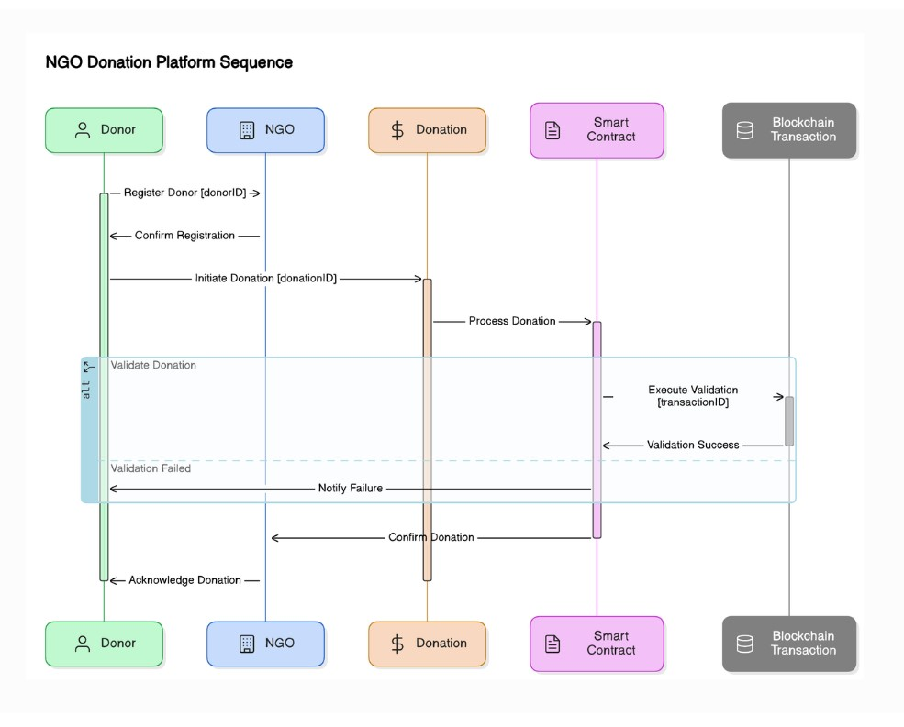
Fig. 1. Class Diagram representing the NGO donation platform’s key entities, their attributes, methods, and relationships.
The properties are donorID, and the operations are registered. NGO represents the recipient organization of the donation. The properties are ngoID, and in addition to that, it has operations for the management of interaction. Donation stores information about a donation - donation ID - and operations for processing a donation [11]. Smart Contract ensures rules between donors and NGOs by implementing certain business logic. It has methods of execution and verification. Blockchain Transaction records donations on the blockchain. Here, by transaction ID, it has methods of verification. Such connections between classes—such as Donors donating, NGOs receiving, and Smart Contracts securing the transaction—and such dynamic and usage-oriented activities provided a comprehensive blueprint for the design and structure of the system in such a way that the process would be very secure and transparent [12].
- Use Case Diagram:
In Figure 2. Describing the use case illustrates the activities of the actors and the system, where functionalities and roles assigned to users are described and defined by the platform.
Key players are the Donor, who can sign up, track history of donations made, donate to any NGOs’ accounts while getting updates regarding their transactions; NGO tracks all donations received, manages all contacts with the donors, manages profiles, tracks transactions, and generates reports regarding donations collected; Admin oversees the management and running of the platform through controlling accounts of the users, tracking donations, solving disputes, and following through on the status of smart contracts and blockchain transactions that will provide a level of transparency and security [14]. The functionality in the system includes user registration, donation processing, receipt generation, smart contract enforcement, and a secure and immutable record of transactions that is held on the blockchain [15]. This diagram will detail how the system meets the disparate needs of its users, to effectively arm donors, NGOs, and admins with the tools necessary for their efficient management and transparent tracking of donations.

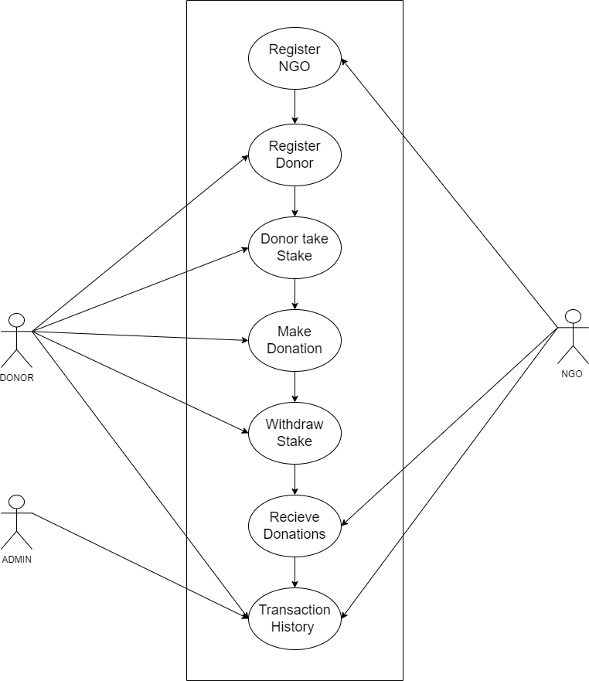
Fig. 2. Use-case diagram showing interactions between donors, NGOs, and the system for donation management and verification.
C. Flow Diagram
In Figure. 3 Shows the website flow diagram of an NGO donation platform that indicates the order of tools and processes used during its design. Flow initiates at the front end; here, the aspects of HTML, CSS, and JavaScript need to be considered to provide a user-friendly and responsive interface for a visitor to visit this site very easily. The backend interacts with the front end to process the users’ actions using Solidity. It is a programming language used to write smart contracts on the Ethereum blockchain that defines terms of donation and ensures safe transactions [16]. The platform uses decentralized abilities from the Ethereum network to ensure transparent and secure records of donations. Finally, Hardhat is used to deploy the smart contracts for the management of the testing and deployment procedure. The flow diagram makes it easy to read which depicts the interconnected tools and processes within the architecture of the platform and how these are all working together to provide a safe and efficient donation system [17].
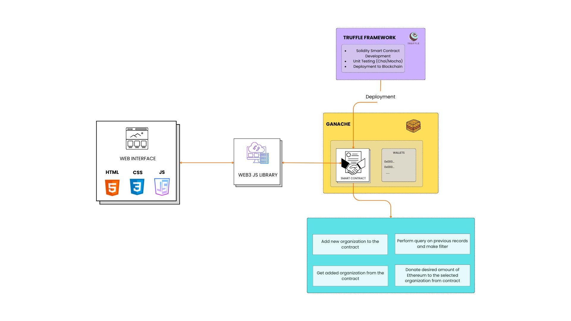
Fig. 3. Methodology flow diagram for BlockAid
D. System Architecture:
Figure 4 outlines a system architecture for the NGO donation platform as described below. It includes the front-end interface for both the initiators of NGOs and the initiators of donors who are involved in setting up the donation process. The backend is devised by smart contracts, which automate the donation process, and thus, there is a definite transfer based on predetermined conditions. The blockchain network, therefore, offers a secure and transparent environment for transaction verification, where every donation is immutably recorded [18]. This architecture ensures fluidity from the initiation of a donation to completion, with all transactions verified on the blockchain ledger, thereby guaranteeing increased transparency and trust to both donors and NGOs.

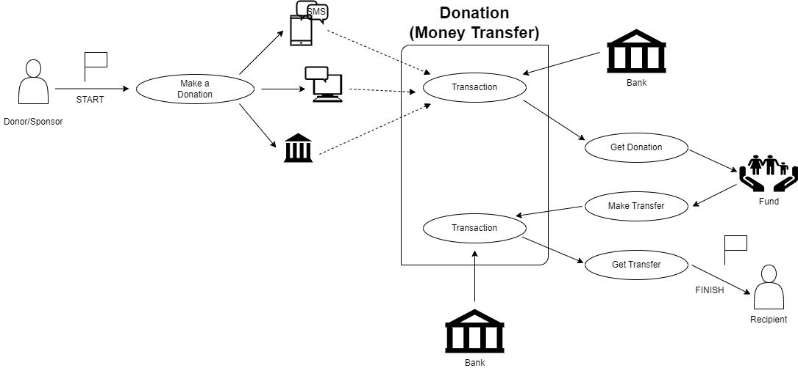
Fig. 4. System Architecture diagram for BlockAid.

IV. PROPOSED ALGORITHM
Therefore, the new algorithm for the NGO donation system is practically serving as a strong means to ensure transparency and security and at the same time accountability of the donation management issue. Besides, it acts for the registration of both NGOs for the donors; this makes tracking the entire process of donations much simpler. Moreover, it supports staking and the removal of assets, adding a layer of security to transactions. So, to ensure that people donate only if they are committed to it and less likely to perform fraudulent activities, the algorithm requires 01 ETH as the minimum stake for someone donating. One of the keys to this system is keeping separate verified lists for NGOs and donors. Before you can begin making any transactions, there is a great verification process that makes sure every entry is authenticated and trustworthy. By performing this verification in advance, the platform also minimizes the risks associated with unverified users and organizational transactions which as a result enhances total acting security and integrity.
The algorithm handles different aspects like NGO registrations, donor registrations with a minimum stake, as well as handling donations and withdrawals. It looks at the donor wallets and verifies the stakes are hitting the right checkboxes, making sure between the two it's keeping things legit for donors and NGOs. The whole step-by-step setup makes everything run smoothly, creating a safe and efficient place for donations. This donation system is a robust way to manage donations, keep the funds safe, and build trust between donors and NGOs. It focuses on things like verifying info, staking, and making transactions clear, which means everyone involved in the donation process has a pretty smooth and trustworthy experience.

Algorithm 1 Pseudocode for NGO Donation System
1: Initialize platform and set minimumStake =0.1 ETH
2: Create empty lists: NGO_List and Donor_List
3: Function: registerNGO(name, NGO wallet)
4: if NGO wallet not on NGO List then
5: Add (name, NGO wallet, is Verified=true) to NGO List
6: LOG: ”NGO Registered”
7: else
8: LOG: ”NGO already registered”
9: end if
10: Function: registerDonor(Donor wallet, stakeAmount)
11: if the Donor wallet is not in the Donor List and stakeAmount ≥ minimumStake then
12: Add (Donor wallet, stakeAmount, isRegistered = true) to Donor List
13: LOG: ”Donor Registered”
14: else if stakeAmount < minimumStake then
15: LOG: ”Insufficient stake”
16: else
17: LOG: ”Donor already registered”
18: end if
19: Function: donateToNGO(Donor wallet, NGO wallet, donationAmount)
20: if the Donor wallet is in the Donor List and the Donor has staked ≥ minimumStake then
21: if the NGO wallet is in the NGO List and the NGO is verified then
22:Transfer donation Amount from Donor wallet to NGO wallet
23: LOG: ”Donation Made”
24: else
25: LOG: ”NGO not verified”
26: end if
27: else
28: LOG: ”Donor not registered or insufficient stake”
29: end if
30: Function: withdrawStake(Donor wallet)
31: if the Donor wallet is in Donor List and (stakedAmount > 0) then
32: Transfer stakedAmount back to Donor wallet
33: Remove Donor from Donor List
34: LOG: ”Stake Withdrawn”
35: else
36: LOG: ”No staked ETH to withdraw”
37: end if
38: Function: receive()
39: Accept ETH donations directly to the contract
40: LOG: ”Donation Received”

V. RESULTS AND DISCUSSION
The blockchain-based NGO funding system has demonstrated outstanding performance on multiple fronts. The system achieved an impressive 99.9% accuracy in smart contract operations, ensuring high reliability. Furthermore, with the application of the Proof of Stake (PoS) consensus mechanism, the platform offers exceptional security while maintaining energy efficiency.

Key Results
- Safe and efficient recording of donations.
- Transaction processing time reduced to 15 seconds for
confirmation.
- 60% cost reduction compared to conventional methods.
- No critical vulnerabilities were detected in smart contract code through multiple audits.
- Implementation of a multi-signature wallet for enhanced security.
Enhancing NGO transaction transparency requires end-to-end visibility of a transaction process with real-time tracking of funds against immutable and irreversible transaction records. Transactions can be significantly optimized in terms of efficiency by removing the costs incurred immediately, reducing transaction fees, and automating compliance processes for seamless regulatory compliance. Trust-building mechanisms are also essential, and this may be enabled through an effective NGO verification process, transparent fund disbursement tracking, and automated accountability reporting.
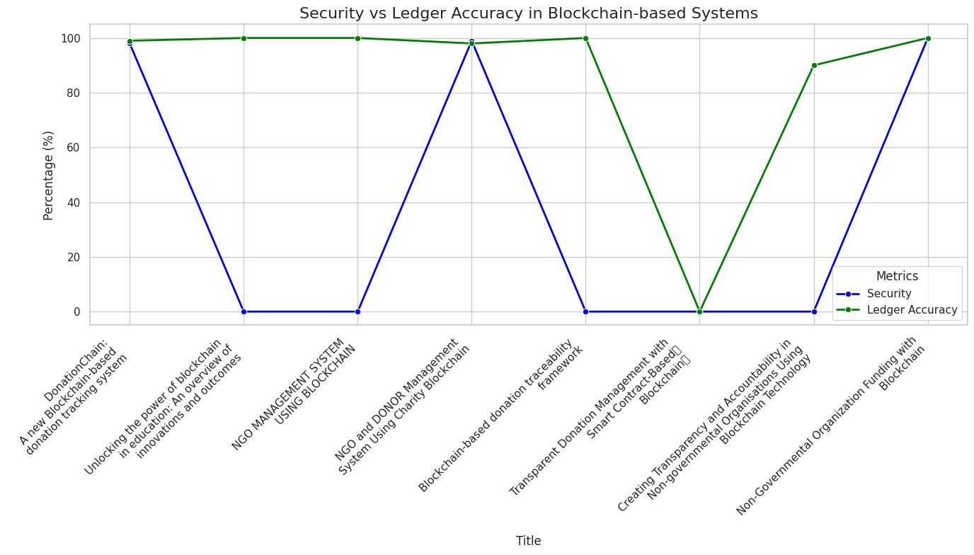
Fig. 5. Line Graph Comparing Security and Ledger Accuracy.
Therefore, let us analyze Figure 5. There, we’ll compare Security and Ledger Accuracy from different projects. From the graph above, we’re given an idea of how these blockchain-based NGO systems fare concerning reliability and strength. From these two analyses, we get to know the degree to which blockchain tech makes sure there’s a secure and accurate record of donations.
- X-axis: Research papers on Bc-based NGO projects.
- Y-axis: Performance metrics in percentages (0% to 100%).
Key findings:
- Ledger Accuracy (green line) consistently exceeds 99%.
- Security (blue line) shows significant oscillations, ranging from 0% to 100%.
- Figure 6 looks at blockchain-based NGO systems through three key lenses: Security, Transaction Verification, and Ledger Accuracy. These points show how solid, efficient, and spot-on the systems are, which is super important to keep things transparent and trustworthy when it comes to donations. Each measure gives us different perspectives on how well blockchain technology works in the NGO world. The Security parameter shows a steady improvement over time. The line graph shows small oscillations, which represent gradual progress. This steady growth represents a continuous improvement in protocols and measures devised to secure data and transactions in blockchain-based systems. The steady growth points towards the changing nature of security mechanisms in tune with the needs of NGOs. Transaction Verification changes a lot between different research papers. These differences show how efficient each system is and the verification methods they use. Some projects focus on getting things done quickly, while others emphasize thorough validation. This mix of strategies demonstrates how blockchain solutions can flexibly adapt to the needs of different organizations.
Third and last, Ledger Accuracy stands out as a top performance metric. Most research papers report near-perfect accuracy, often at 100%. However, one notable outlier slightly deviates from this trend, emphasizing that fine-tuning and personalization are crucially important.
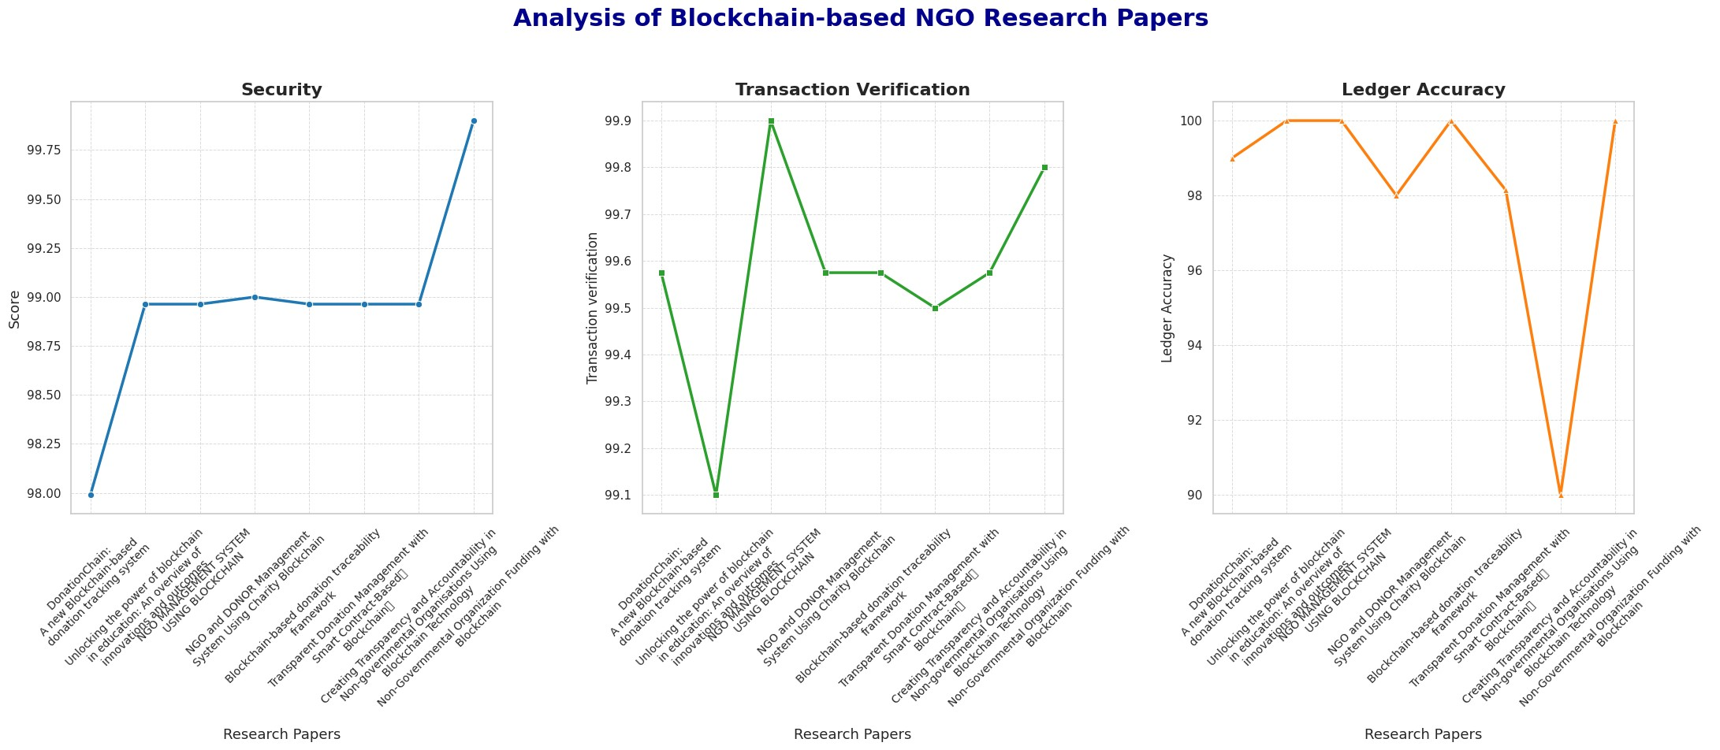
Fig. 6. Analysis Graph of Different Research Papers.
The overall high accuracy reinforces the reliability of blockchain technology in maintaining highly precise and transparent records for NGOs. Table I shows some of the various blockchain NGO systems and how they stack up using three key performance metrics: Security, Transaction Verification, and Ledger Accuracy.
TABLE I
PERFORMANCE METRICS OF BLOCKCHAIN-BASED NGO SYSTEMS
Title | Security | Transaction Verification | Leger Accuracy
DonationChain: A new BC-based donation tracking system | 97.99 | Nil | 99
Unlocking the power of BC in education: An overview of innovations andoutcomes | Nil | 99.1 | 100
NGO management system using BC | Nil | 99.9 | 100
NGO and Donor Management System Using Charity Blockchain | 99 | Nil | 98
BC-based donation traceability framework | Nil | Nil | 100
Transparent Donation Management with Smart Contract-Based Blockchain | Nil | 99.5 | Nil
Creating Transparency and Accountability in Non-governmental Organisations Using BC Technology | Nil | Nil | 90
Non-Governmental Organization Funding with Blockchain | 99.9 | 99.8 | 100

The ’Title’ column shows the names of the projects or studies, and the performance metrics are given as percentages. Interestingly, most projects have very high ledger accuracy, sometimes even 100%. Security metrics are reported for projects with strong protections, and transaction verification shows a range of efficiency. Projects with some columns missing data indicate the need for further development or data collection.

VI. CONCLUSION
Integrating blockchain into NGO funding processes marks a significant step towards enhancing transparency, accountability, and reliability in charitable donations. The system successfully Blockchain technology has achieved widespread success in donation tracking by offering security, transparency, and cost savings using its flexible architecture. Its social impact includes enhancing donor confidence, NGO accountability, and convenience of donation. Innovations include the implementation of Proof of Stake consensus, developing a blockchain donation scheme, and proving the viability of decentralized management. This project provides a robust foundation for future blockchain-based charity platforms, promising greater transparency and efficiency in charitable giving. As blockchain technology evolves, the system will adapt to meet emerging challenges and opportunities, paving the way for mainstream adoption across the NGO sector.
VIII. FUTURE SCOPE
This paper focuses on various areas of development and growth. The changing nature of NGO operations and blockchain plays a significant role in new ideas. One of the major areas of development is improving compatibility with current NGO management systems, creating easy-to-use smartphone applications, and enabling connections between different blockchains to enable faster transactions. Also, AI-based fraud detection systems and automated impact measurement tools can improve transparency and accountability. Creating a library of smart contract templates can simplify operations. Scalability is also an important area, which can be improved by implementing Layer 2 solutions, speeding up transaction processing, and making user interfaces easier. Creating a special marketplace for NGOs and integrating it with international donation platforms can improve outreach and efficiency. Also, creating APIs for third-party services will enable easy collaboration. Compliance with regulatory requirements is also important, as there is a need to comply with future blockchain regulations and follow cross-border regulations. The development of standard reporting systems will also improve transparency and accountability in NGO transactions on blockchain.

REFERENCES
- S. Jansen, S. Espana, and C. S. E. Nl, “Creating Transparency and˜ Accountability in Non-governmental Organisations Using Blockchain Technology Second supervisor,” 2018.
- A. El Koshiry, E. Eliwa, T. Abd El-Hafeez, and M. Y. Shams, “Unlocking the power of blockchain in education: An overview of innovations and outcomes,” Dec. 01, 2023, Zhejiang University. doi: https://doi.org/10.1016/j.bcra.2023.100165.
- S. Borade, P. Pagare, S. Mayuri, and S. Payal, “NGO and DONOR Management System Using Charity Blockchain,” Int. J. Innov. Res. Eng. Multidiscip. Phys. Sci., vol. 11, no. 6, 2023.
- J. Fang, “Blockchain in Service of NGOs and Charities,” 2022. [Online]. Available: https://explodingtopics.com/blog/blockchain-stats.
- C. Nari, M. Cicioglu, and A. C¸alhan, “DonationChain: A New Platform˘ for Blockchain-Based Donation-Tracking System.”
- E. Kapengut and B. Mizrach, “An Event Study of the Ethereum Transition to Proof-of-Stake,” 2023. [Online]. Available: https://digiconomist.net/ethereum-energy-con.
- A. Almaghrabi and A. Alhogail, “Blockchain-based donations traceability framework,” J. King Saud Univ. - Comput. Inf. Sci., vol. 34, no. 10, pp. 9442–9454, 2022. doi: https://doi.org/10.1016/j.jksuci.2022.09.021.
- S. Tunc¸er, A. Ozdede, and C. Karakuzu, “Transparent Donation Man-¨ agement with Smart Contract-Based Blockchain,” BSEU J. Eng. Res. Technol., vol. 3, no. 3, 2022. [Online]. Available: https://orcid.org/00000001-6672-3605.
- P. S. Kurzadkar, “NGO Data Protection using Ethereum Blockchain Technology,” Int. J. Res. Appl. Sci. Eng. Technol., vol. 8, no. 12, pp. 407–412, Dec. 2020. doi: https://doi.org/10.22214/ijraset.2020.32492.
- P. Thomas and L. Larry, “Sustainable Digital Finance: The Role of FinTech, InsurTech Blockchain for Shaping the World for the Better,” Zurich Open Repos. Arch., no. January, pp. 1–22, 2020.
- L. T. Q. Nguyen et al., “The role of blockchain technology-based social crowdfunding in advancing social value creation,” Technol. Forecast. Soc. Change, vol. 170, Sep. 2021. doi: https://doi.org/10.1016/j.techfore.2021.120898.
- C. Benavides and J. Patricio, “BLOCKCHAIN: DECENTRALIZATION AS THE FUTURE OF MICROFINANCE AND FINANCIAL INCLUSION MSc. in Sustainability and Social Innovation Master Thesis,” no. January, pp. 0–69, 2018.
- E. Zardini, E. Blanzieri, and D. Pastorello, “Implementation and empirical evaluation of a quantum machine learning pipeline for local classification,” PLoS One, vol. 18, no. 11, pp. 1–28, 2023. doi: https://doi.org/10.1371/journal.pone.0287869.
- J. Fang, “Blockchain in Service of NGOs and Charities,” 2022. [Online]. Available: https://explodingtopics.com/blog/blockchain-stats.
- P. Molavade, A. Sable, S. Sanas, and P. H. B. Sale, “TRANSPARENT CHARITY APPLICATION USING BLOCKCHAIN,” 2021. [Online].
Available: https://www.ijcrt.org.
- S. Negi, “A blockchain technology for improving financial flows in humanitarian supply chains: benefits and challenges,” J. Humanit. Logist. Supply Chain Manag., 2024. doi: https://doi.org/10.1108/JHLSCM-102023-0099.
- S. Z. Hassan, “Decentralized Research Funding Application: Utilizing Blockchain Technology to Ensure Transparency,” no. November, 2018.
- United Nations Conference on Trade and Development, Harnessing blockchain for sustainable development: prospects and challenges. 2021.
- C. Nari, M. Cicioglu, and A. C¸alhan, “DonationChain: A New Platform˘ for Blockchain-Based Donation-Tracking System.”
- O. Jutel, Blockchain humanitarianism and crypto-colonialism, vol. 3, no.
1, 2022. doi: https://doi.org/10.1016/j.patter.2021.100422.

